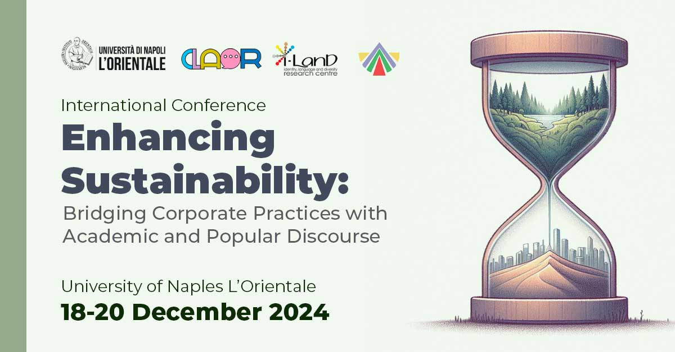

**International Conference**

***Enhancing Sustainability: Bridging Corporate Practices with Academic and Popular Discourse***

18-20 December 2024

*Palazzo Du Mesnil, Sala Conferenze*

*Via Chiatamone 61/62*

*Napoli, Italy*

A complex, “contentious concept” (Catenaccio, 2019: 208), sustainability is the subject of interdisciplinary interest, spanning several research areas and occupying a central role in recent international literature (see Krieg and Toivanen, 2021) in its attempt to contribute to “th[e] ecological transformation founded on shared democratic values [...]” (Brüggemann *et al.*, 2023: 5039). Due to its multifaceted nature, sustainability has largely entered popular discourse, opening to several theoretical and methodological approaches for the analysis of different genres and text types. One the one hand, language and discourse studies have explored the persuasive nature of sustainability communication – “how emotions are triggered by language and performance and then channelled within the minds of the people in an audience” (Burke, 2023: 22). On the other hand, they have underlined how dialogue between the various stakeholders is crucial to creating mutual understanding and “introduc[ing] new discourses that may open up new directions in how companies contribute to sustainability” (Higgins and Coffey, 2016: 18).

Based on these premises, the conference aims to promote an in-depth understanding of sustainability communication while providing innovative insights and practical solutions to current sustainability challenges. The event is intended as a meeting place for local companies, academia, and other subjects (e.g. from media, film and television) to exchange knowledge and practices, improve communication, and expand theoretical, methodological, and practical approaches to the study of sustainability.

Papers selected for the conference will take a close look at sustainability in its linguistic, discursive, multimodal, and pragmatic aspects. Topics for contributions in English include, but are not limited to:

- sustainability communication across media and text types

- persuasive and effective sustainability communication

- digital sustainability communication (i.e. on social media)

- multimodal representations of sustainability

- framing and discursive construction of sustainability

- discursive polarisation around sustainability topics

- LSP and popularisation of sustainability specialised knowledge

- criticism and limitations of sustainability as theory and practice

- sustainability best practices and corporate strategies

- interdisciplinary features of sustainability

Theoretical and methodological approaches include, among others: (critical) discourse analysis, corpus linguistics, multimodal (critical) discourse analysis, media and film studies, communication studies, corporate communication, digital humanities, pragmatics, stylistics, sociolinguistics, comparative studies, translation studies, and literary studies.

**Essential references**

Alexander R., 2010, *Framing Discourse on the Environment: A Critical Discourse Approach*, London: Routledge.

Brüggemann M., Carvalho A., Brevini B., Downey J., 2023, “Still Watching from the Sidelines? The Case for Transformative Environmental Communication Scholarship”, *International Journal of Communication* 17, 5039-5052.

Burke M. (ed.), 2023, *The Routledge Handbook of Stylistics*, London: Routledge.

Catenaccio P., 2019, “Ethics and Legitimacy in the Discourse of Agri-biotechnology. A Study in Argumentation”, *Anglistica AION* 23(1), 195-216.

Christen M., Schmidt S., 2012, “A Formal Framework for Conceptions of Sustainability. A Theoretical Contribution to the Discourse in Sustainable Development”, *Sustainable Development* 20, 400-410.

Fill A.F., Mühlhäusler P., 2001, *The Ecolinguistics Reader*, London & New York: Continuum.

Fischer D., Reinermann J.L., Mandujano G.G., DesRoches C.T., Diddi S., and Vergragt P.J., 2021, “Sustainable consumption communication: A review of an emerging field of research”, *Journal of Cleaner Production* 300, 126880.

Godemann J., Michelsen G., 2011, *Sustainability Communication. An Introduction*, Springer Netherlands.

Hajer M., Versteeg W., 2005, “A Decade of Discourse Analysis of Environmental Politics: Achievements, Challenges, Perspectives”, *Journal of Environmental Policy & Planning* 7(3), 175-184.

Higgins C., Coffey B., 2016, “Improving how Sustainability Reports drive Change: A Critical Discourse Analysis”, J*ournal of Cleaner Production* 136(A), 18-29.

Krieg C., Toivanen R. (eds.), 2021, *Situating Sustainability: A Handbook of Contexts and Concepts*, Helsinki: Helsinki University Press.

**Keynote speakers**

Michael Burke (Utrecht University)

Anabela Carvalho (University of Minho)

Paola Catenaccio (State University of Milan)

**Important dates**

Abstracts up to 250 words (max 5 references excluded) should be sent to: [enhancingsustainability@gmail.com](mailto:enhancingsustainability@gmail.com)

**Deadline for abstract submissions:** ~~September 8, 2024~~ September 30, 2024

**Notification of acceptance:** September 23, 2024

**Registration:** September 23, 2024 – December 10, 2024

**Conference dates:** December 18-20, 2024

Please, include: title; name; affiliation; email address; a short bio-biographical sketch (max 100 words); up to 5 keywords.

Each talk selected for presentation will be allotted 20 minutes followed by 10 minutes for discussion.

**Fees** (registration costs, lunch, coffee breaks)80€

**Scientific committee**

Giuseppe Balirano (University of Naples ‘L’Orientale’)

Michael Burke (Utrecht University)

Anabela Carvalho (University of Minho)

Paola Catenaccio (University of Milan)

Bianca Del Villano (University of Naples ‘L’Orientale’)

Francesco Nacchia (University of Naples ‘L’Orientale’)

Marina Niceforo (University of Naples ‘L’Orientale’)

Katherine E. Russo (University of Naples ‘L’Orientale’)

**Organising committee**

Maria De Santo (University of Naples ‘L’Orientale’)

Roberto Esposito (University of Naples ‘L’Orientale’)

Francesco Nacchia (University of Naples ‘L’Orientale’)

Marina Niceforo (University of Naples ‘L’Orientale’)

Annalisa Raffone (University of Naples ‘L’Orientale’)

Giuseppina Scotto di Carlo (University of Naples ‘L’Orientale’)

**Venue:**

University of Naples ‘L’Orientale’, Palazzo Du Mesnil, Via Chiatamone, 61/62, Naples, Italy.

**_______________________________________________________________________________**

The conference will be in person only. The language of the conference is English.

For more information and updates about the conference, please send an email to [enhancingsustainability@gmail.com](mailto:enhancingsustainability@gmail.com) or follow us on [Facebook](https://www.facebook.com/share/SAg8LNaaxYL79zhF/) and [X](https://x.com/EnhancingSust).

For more information about the University of Naples ‘L’Orientale’, please visit our website [www.unior.it](http://www.unior.it)