Call for papers: International Journal of Marketing Semiotics & Discourse Studies Vol.VII (2019) AND 3 IMPORTANT ANNOUNCEMENTS
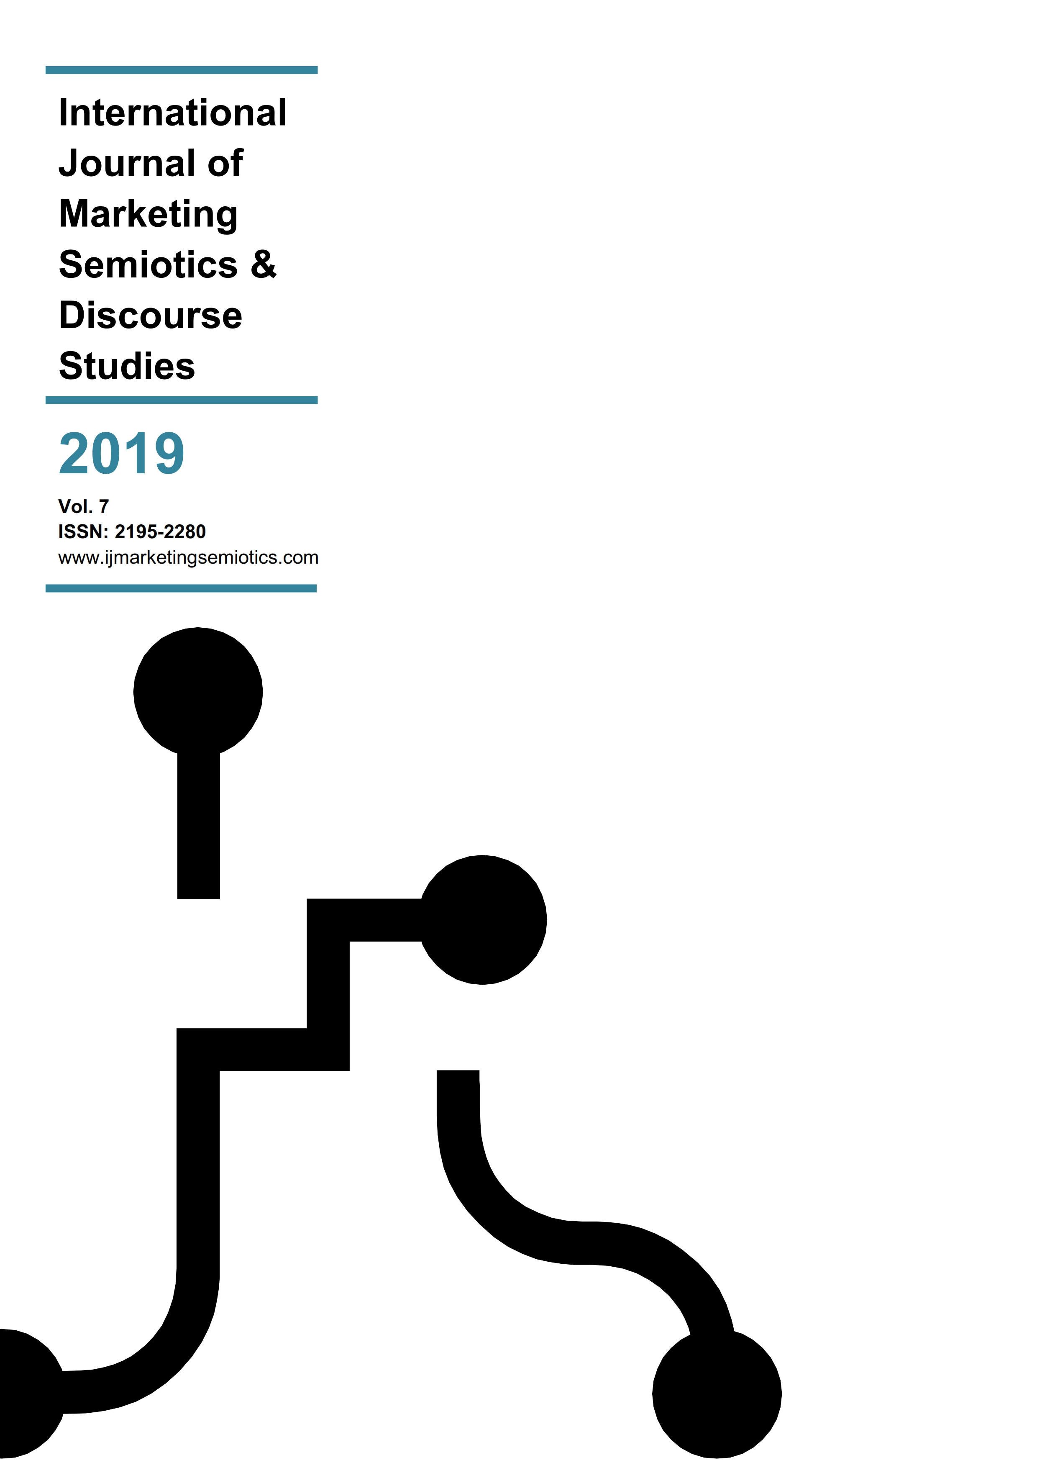
www.ijmarketingsemiotics.com
included in
Submissions for Vol. VII are accepted from now and until the end of 2019 and will be published immediately upon acceptance based on our new all-year-round publishing policy (see relevant announcements).
The International Journal of Marketing Semiotics & Discourse Studies welcomes both conceptual and applied academic research, but also provides a forum where marketing semiotics agencies may publicize case studies of projects they have undertaken for clients.
Acceptable contents and content formats include the following:
- Academic conceptual and empirical research papers (see Submission Guidelines @ https://ijmarketingsemiotics.com/submission-guidelines-2/)
- Practitioners’ (agencies’) case-studies
- Academic presentations (either as part of taught curricula or as delivered in academic conferences)
- Full books or individual chapters (either printed or in print)
- Book reviews

- If you wish to contribute to the International Journal of Marketing Semiotics & Discourse Studies, please send your content to:
- Dr. George Rossolatos
- email: georgerossolatos123@gmail.com

Important announcements
- EVEN DEADLINES CAN DIE: AS OF NOW AND THROUGHOUT 2019 IJMS&DS IS ADOPTING AN ALL-YEAR-ROUND PUBLISHING POLICY. HOW YOU MAY BENEFIT FROM SUBMITTING YOUR RESEARCH TO IJMS&DS:
- Fast review turn-arounds (one month on average)
- Immediate publication upon acceptance under the same annual volume
- No more endless deadlines (for you) and last minute bulk submissions (for us)
- 100% narrow-targeting a research community that is interested in cross-disciplinary between discourse analysis/semiotics and marketing streams.

- REBRANDING of the International Journal of Marketing Semiotics into International Journal of Marketing Semiotics & Discourse Studies as of September 2018.
- Accommodating more explicitly under the same conceptual umbrella the rapidly emerging field of inter-disciplinary studies between marketing research territories and the sister disciplines of semiotics and discourse analysis.
- A trend precipitated by new media studies and the progressive migration of social theoretic foci to a Web 2.0 environment, as well as the increasing convergence between media and marketing studies.
- Increasing adoption of a pan-consumptivist outlook in the scrutiny of cultural phenomena in cultural studies, cultural sociology, cultural anthropology which share discourse analytic methodological routes.
- Increasing prominence of multimodality in both semiotic and discourse analytic terms.

- Call for New Editorial Board Members
- If inter-disciplinary research between discourse analysis/semiotics and marketing lies within your focal areas and you are committed to contribute substantially to this burgeoning stream, then you are welcome to join the Editorial team at the International Journal of Marketing Semiotics & Discourse Studies.
- Facts & Figures
  - Established in 2012 and 6 volumes, 10000 unique visitors down the line, IJMS&DS is currently the only journal that targets narrowly the research community that looks into ways of advancing inter-disciplinary research between marketing and semiotic/discourse analytic perspectives.
  - Listed with SCOPUS ever since Vol.III
  - With a vibrant Facebook community where news, reading materials and useful content are regularly posted
  - Recognized by both the marketing and semiotics research communities
- Send your bio note / CV (email: georgerossolatos123@gmail.com) and a link to your research, and become part of a rapidly growing community of researchers.
About IJMS&DS
The International Journal of Marketing Semiotics & Discourse Studies is an open-source, double blind-reviewed academic journal that covers a wide spectrum of interdisciplinary marketing/semiotic/discourse analytic research streams, spanning:
- Conceptual approaches and empirical research across the 5 P's by drawing on different semiotic (post-structuralist, sociosemiotic, Peircean, structuralist, cultural, textual, visual, multimodal) and discourse analytic (CDA, DHA) perspectives.
- Consumer cultural theory and research
- Cultural experiences, artefacts, practices, spectacles
- In virtual, ‘real’, hyperreal environments
- In individual or community settings
- Methodological frameworks for conducting research into product/service/retail branding, brand identity development, brand equity, packaging design, competitive packaging analysis, new product development, pricing, advertising, IMC development and competitive analysis, consumer behavior (offline and online).
- Comparing and contrasting existing marketing research conceptual and methodological frameworks with discourse analytic/semiotic ones.
- Cross-disciplinary approaches on marketing research issues that combine discourse analysis and semiotics with perspectives from the social sciences and the humanities, such as anthropology, literary studies, psychoanalysis, anthropology, rhetoric, sociology.

