International Journal of Marketing Semiotics & Discourse Studies
Vol.VII (2019)
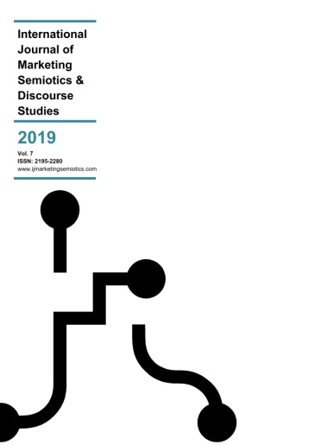
Online first: 13 April 2019
Antonio Laurino (2019). Amongst branding, design and architecture: a semiotic analysis of ING DIRECT’s bank shops. International Journal of Marketing Semiotics & Discourse Studies Vol. VII, pp.1-20.
https://ijmarketingsemiotics.com/journal-contents-2/
Submissions for Vol. VII are accepted from now and until the end of 2019 and will be published immediately upon acceptance based on our new all-year-round publishing policy.
The International Journal of Marketing Semiotics & Discourse Studies welcomes both conceptual and applied academic research, but also provides a forum where marketing semiotics agencies may publicize case studies of projects they have undertaken for clients.
Acceptable contents and content formats include the following:
- Academic conceptual and empirical research papers (see Submission Guidelines @ https://ijmarketingsemiotics.com/submission-guidelines-2/)
- Practitioners’ (agencies’) case-studies
- Academic presentations (either as part of taught curricula or as delivered in academic conferences)
- Full books or individual chapters (either printed or in print)
- Book reviews
If you wish to contribute to the International Journal of Marketing Semiotics & Discourse Studies, please send your manuscript to: Dr. George Rossolatos, email: georgerossolatos123@gmail.com

